OCTOBER GLOW
“Gals Living Our Witness”
All women of American Lutheran Church are members of GLOW!
Our Purpose Statement: “As a community of women created in the image of God, called to discipleship in Jesus Christ and empowered by the Holy Spirit we commit ourselves to grow in faith, affirm our gifts, support one another in our callings, engage in ministry and action, and promote healing and wholeness in our church, our society and our world.”

Jubilee Market & Peacemeals and Care & Share Shop
Thursday, October 11, 11:45 a.m.
Meet at the church at 11:45 a.m. to ride the bus to Jubilee Market & Peacemeals in Mt. Lake. We will enjoy a tour of the facility and a soup and sandwich lunch at your own expense. After lunch, we will visit the Care and Share Shop which also houses the Ten Thousand Villages store.
Sign up on the bulletin board by the office and indicate your soup and sandwich choice by Monday, October 8.

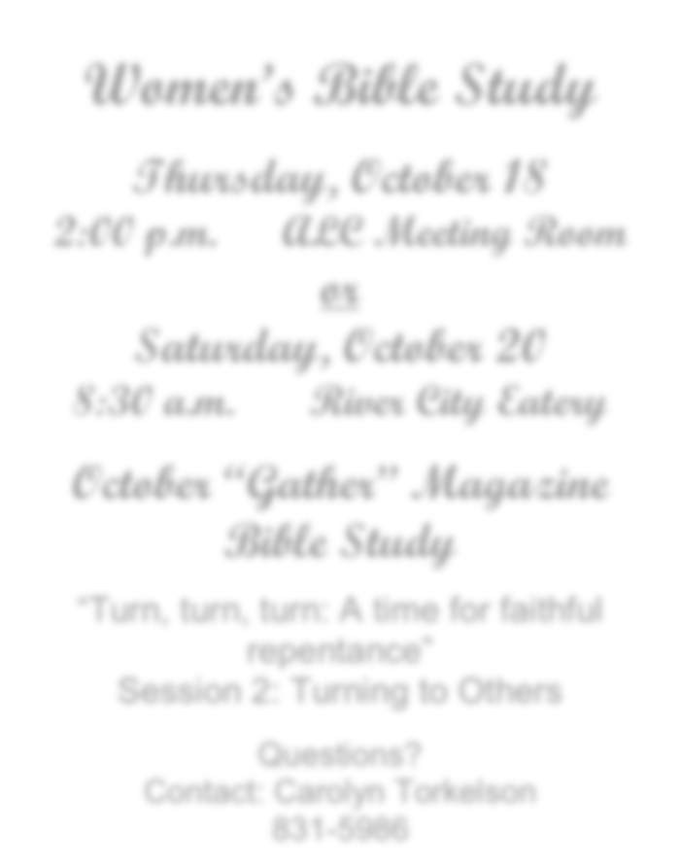

Women’s Bible Study
Thursday, October 18
2:00 p.m. ALC Meeting Room or
Saturday, October 20
8:30 a.m. River City Eatery

October “Gather” Magazine Bible Study

“Turn, turn, turn: A time for faithful repentance”
Session 2: Turning to Others

Questions?
Contact: Carolyn Torkelson 831-5986

GLOW planning meeting for 2019
Sunday, October 21 10:00 a.m.
Meeting room by the office

All women are welcome to come and share ideas for 2019 activities. If you would like to be a part of the leadership team, come to the meeting and volunteer. “Many hands make light work” (and lots of fun)!
American Lutheran Church Women's Ministry 2018

